SMTP: final words
▪ SMTP uses persistent connections
▪ SMTP requires message (header & body) to be in 7-bit ASCII
▪ SMTP server uses CRLF.CRLF to determine end of message

comparison with HTTP:
▪ HTTP: pull
▪ SMTP: push
▪ both have ASCII command/response interaction, status codes
▪ HTTP: each object encapsulated in its own response message
▪ SMTP: multiple objects sent in multipart message

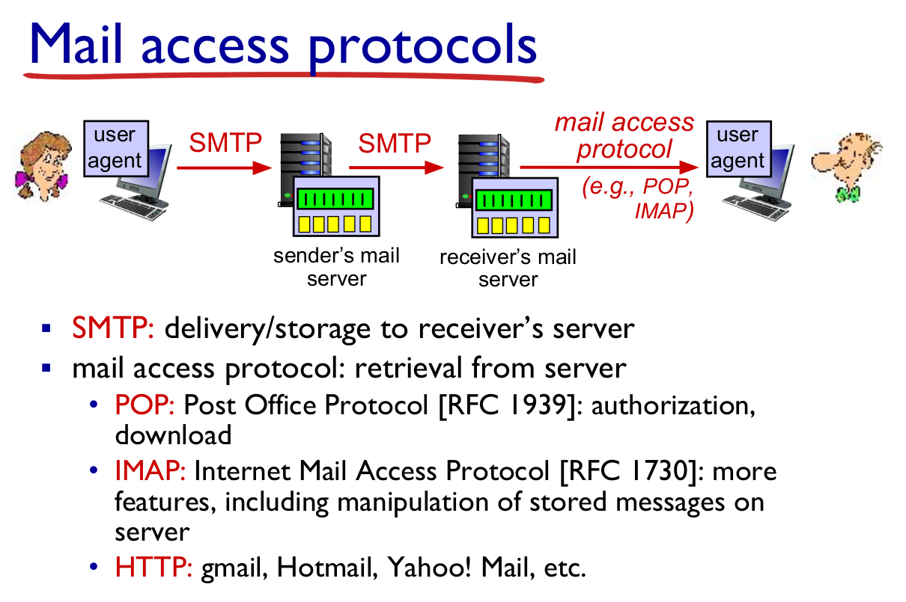

TCP Header:

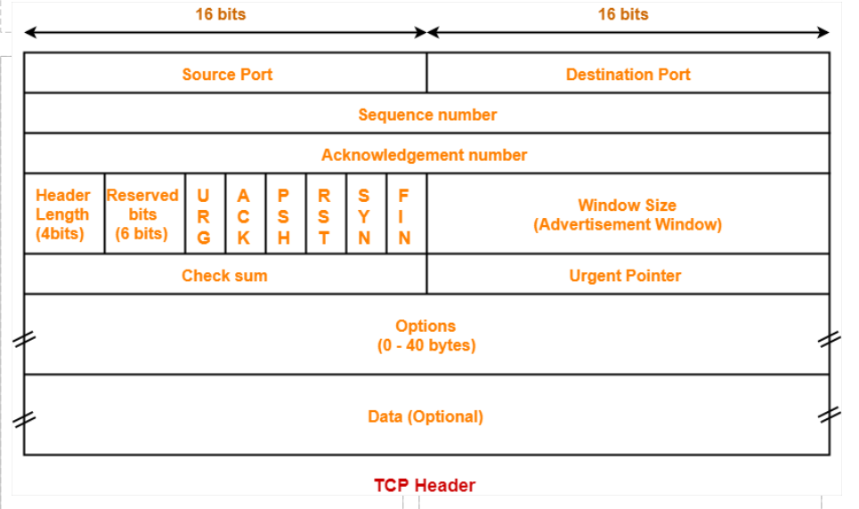
UDP Header:

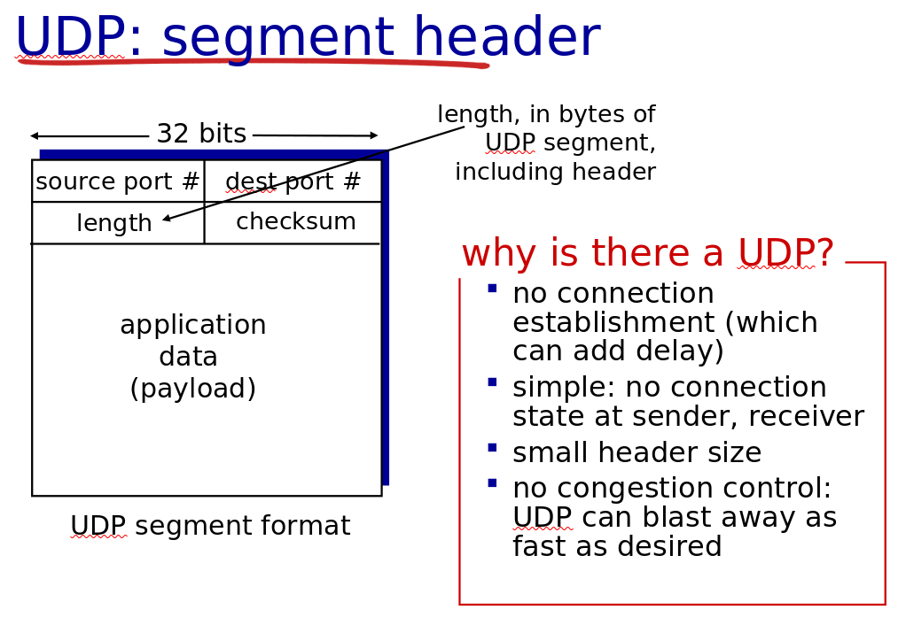
Go Back N:
